Balla Golf Club
Calendar of Events 2018

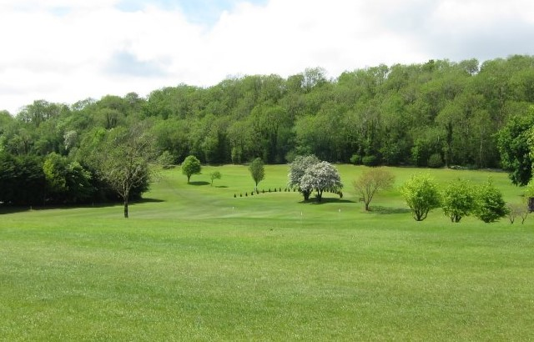

Captain: Paul Murtagh
Lady Captain: Julie Loftus
President: Carmel Henry

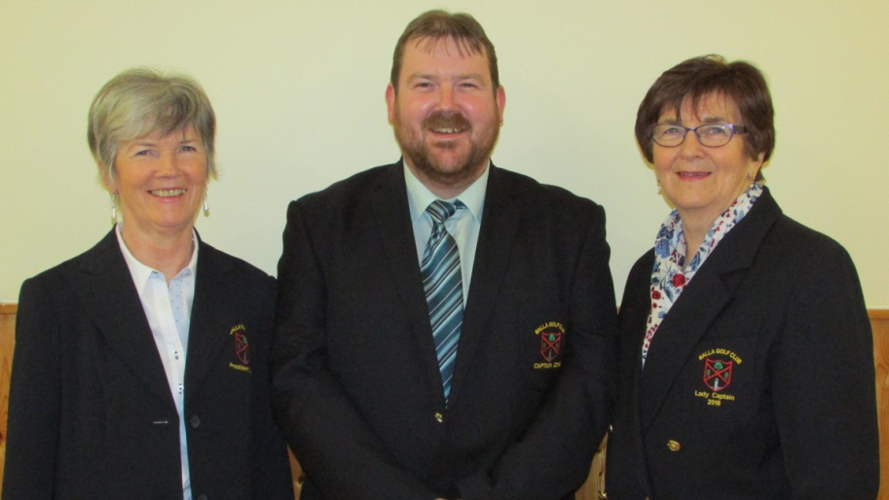

Website: www.ballagolfclub.com
E-mail: ballagolfclub@hotmail.com
Phone: 094 9365470 Mobile: 087 3814440

DATE W.E. | COMPETITION | SPONSOR
8th April | Captains’ Drive-In - Scramble | McEllins Plant Hire
15th April | Stableford | Hursts Heating & Plumbing
22nd April | Stableford | Shaws
29th April | Stroke GOY | Abbeybreaffy Nursing Home
7th May | Open Stableford | Bar One
13th May | Stableford | Castle Davitt Furniture
20th May | Stroke GOY | Roches Centra – Joe Leavy Mem.
27th May | Stableford | Western Farming Co-Op
3rd June | Fundraiser | Mulranny Park Hotel
4th June | Open Stableford | Albany, Castlebar
10th June | Presidents Day (Carmel Henry) GOY | Treacys Pharmacy; Clew Bay Bar & Restaurant; Nigel Reape Office Supplies, The Olde Woods, McDonalds Restaurant
17th June | Stableford | Lawnmower & Tool Hire
24th June | Rumble | Room for a Rug
1st July | Stableford | Unit 7
8th July | Lady Captains Day (Julie Loftus) GOY | PEL; Mayo Leisure Centre; Lavins Foods; The Shebeen Golf Society; Baxter
15th July | Stableford | Supervalu Castlebar
22nd July | Stableford | Gerry Tolster
28th July to 6th August | 3 Ball Classic | The Helm; Eddie Egans Jewellers; Lydia Nails; The Dalton Inn; Mannions Golf Society; Al Murettas; Stauntons Pharmacy
12th Aug | Stableford | Cox's – Balla Cup
19th Aug | Stroke GOY | Cashins Printing
26th Aug | Stableford | Corrib Oil
1st Sept | Ladies Section of Mens Captains Day GOY | Bernie Fallon & Sons; The Shebeen; Elverys Sports; Pat Nestor Belcarra Ltd; Mercury Security Management; Atlantic IT
31st Aug & 2nd Sept + 7th & 9th Sept | Stableford
8th Sept | Captains Day (Paul Murtagh) GOY
16th Sept | Waltz | Parsons Shoes & OK Ltd
23rd Sept | Stableford | Sean & Maureen McDonnell
30th Sept | Stroke GOY | Golf Style
7th Oct | Stableford | Brant Rock
14th Oct | Stableford | APM Securities & JT Sports
21st Oct | Stroke GOY | Vaughans Shoes & Brendans Bus Hire
29th Oct | Open Stableford | Sheridan Electrics
4th Nov | Stableford | Kilcoyne & Scahill
11th Nov | Stableford | T.V.R.C.N & Rockys

Mid Week Scrambles
4th April | Credit Union
11th April | Cuffe Car Sales
18th April | PJ Byrne Monumental Works
25th April | Supervalu, Kiltimagh
2nd May | Aiden Moran Driving Range
9th May | Cllr. Al McDonnell
16th May | M & C Financial Services
23rd May | John O'Donnells Pharmacy
30th May | Cunniffes Garden Centre
6th June Pre Presidents Day Scramble | Sean Canny Tyres / Walshes Timber Floors
13th June | Moylettes Plumbing & Heating
20th June | Balla Florists
27th June | Heiton Buckleys
4th July Pre Lady Captains Day Scramble | The Helm / Declan Biggins
11th July | Paul Cunningham Costcutters
18th July | Mary Staunton Memorial
25th July | Coffeys Life Pharmacy
8th August | Mannions Golf Society
15th August | Doherty Menswear
22nd August | The Bay Leaf
29th August | Woodies
5th September Pre Captains Day Scramble | Paul & Aisling / Harringtons
12th September | McGraths Waste & Dunnes Stores
19th September | Padraic McHale
26th September | Connaught Inn
3rd October | Pamela Scotts
10th October | Albany, Claremorris
17th October | Heneghans Pharmacy
24th October | Vincent Deane Solicitor
31st October | The Rendezvous

Winter League sponsored by Paul Cuffe Auto Repairs,AIB, Permanent TSB & Jones Oil
Christmas Hamper Competition sponsored by Mulroys Supermarket
Christmas Scramble Sponsored by Junior Prendergast
Other sponsors: CT Electrics; Beauty by Helen, Tesco,
Cup Competitions
Joe O'Brien Cup - Sponsored by Joe O'Brien
Broderick Cup - Sponsored by Jimmy Broderick
Scratch Cups – Mid West Mowers & Michael O’Malley Tarmacadam
Golfer of the Year - Sponsored by Mayo Crystal
Note: To qualify for 1st prize on Presidents Day you must have 3 score cards submitted and to qualify for 1st Prize on Captains or Lady Captains Day 5 cards must be submitted – re-entry cards not eligible

